

Tiny Machines Working to Elucidate Mechanisms of Cerebrovascular Pathologies

CMT-DN Mobility Declaration
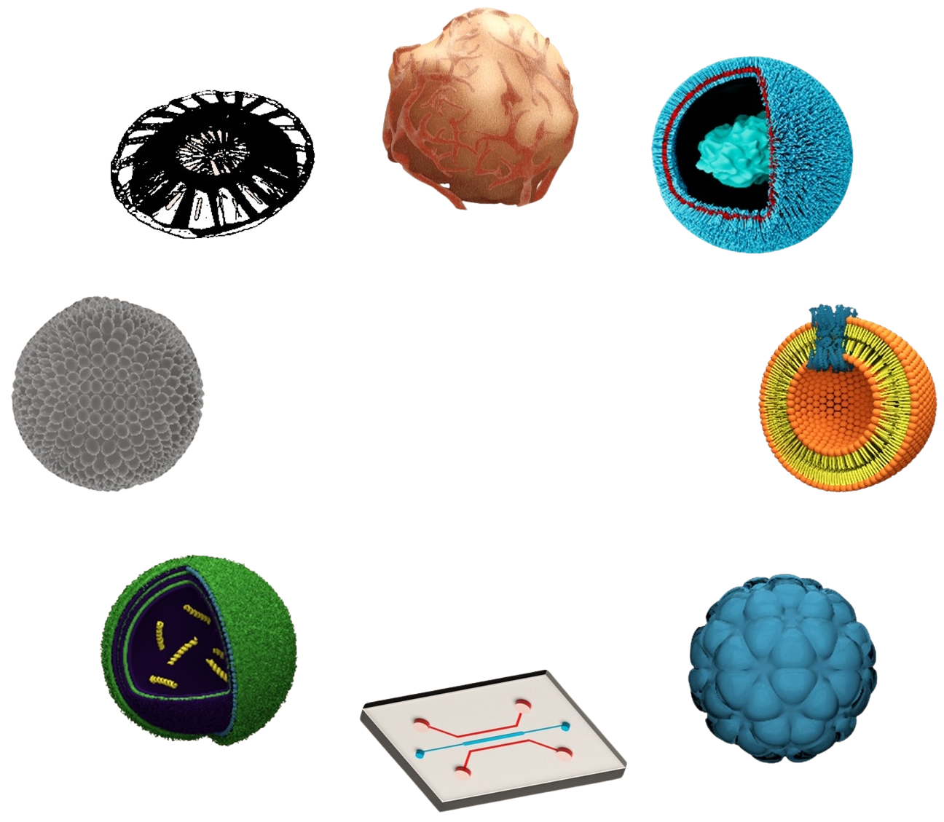
Project ID | 101227628
Project Title | Tiny Machines Working to Elucidate Mechanisms of Cerebrovascular Pathologies
Project Short Title | CerebroMachinesTrain Doctoral Network
Project Acronym | CMT-DN
Project Start Date | 01 Jan 2026
Project Duration | 48 months
Project Website | https://cmt-dn.eu/
Project Email | CMT-DN@universityofgalway.ie
Applicant Name | {Add here Lastname Firstname}
Applicant E-mail Address | {Must match the e-mail on the Application Portal}
Applicant Nationality | {Add Nationality here}

 | This project has received funding from the European Union’s Horizon Europe research and innovation programme under the Marie Skłodowska-Curie Actions Grant Agreement No 101227628.  This document reflects the views of the author(s) and does not necessarily reflect the views or policy of the European Commission. The REA cannot be held responsible for any use that may be made of the information this document contains.

Instructions
In addition to the information provided in the application portal, you must also provide in the form below a detailed history of where you have lived, worked or studied since 1st January 2023 up to 31st August 2026. If you plan to move between the date of filling out the form and the 31st of August, you must include this on the form below.

Short stays, such as holidays, are not taken into account.

You do not need to provide a full address; the country and region/major city are sufficient.

Please ensure that this file is named correctly in the format Lastname_firstname.pdf. e.g. Curie_Marie.pdf

For further information, see the CMT-DN website

Declaration
I certify that this document contains a truthful account of my mobility history from 1st January 2023 to 31st August 2026. I can, if requested, provide proof of this history through university registration documents, utility bills or other official documents or correspondence.

Full Name:

Signature:

Date:

Please list all locations on the table below, starting with the most recent.
No. Crt. | Location | Start Date (DD/MM/YYYY) | End Date (DD/MM/YYYY) | Country | Region/City | Main activity
1
2
3
4
5
6
7
8
9
10
Add additional rows as needed.

